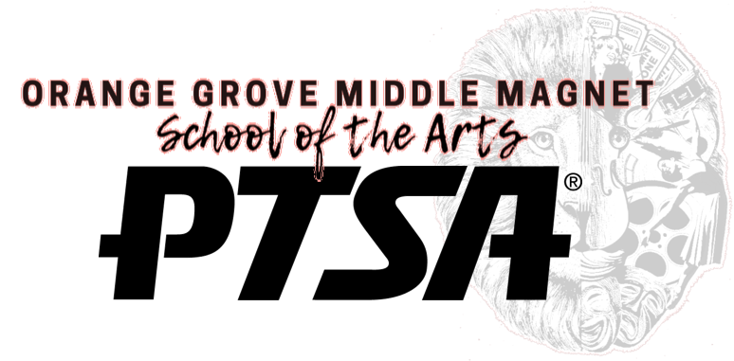

General Membership Meeting
Minutes
March 31, 2023

- Welcome / Call to Order @ 5:50pm - Holly Waldron
- Pledge – Holly Waldron
- Establish Quorum – quorum established (Holly Waldron, David Waldron,
Betsie Zeedyk, Bill Zeedyk, Kim Lloyd, Jim Lloyd, Heather Grahek, Olivia Grahek, Shemida Joseph, Deb Babb)
- Items for Approval – Holly Waldron
  - Approval of Minutes from August, 2022 – minutes approved
  - Approval of 2022-2023 Budget Amendments – fundraiser totals adjusted for actual amount, mini grant monies reduced, added grant money from ‘take down tobacco’ initiative, added money to teacher appreciation week to balance budget
  - Approval of Nominating Committee – Betsie Zeedyk (temporary chairwoman), Kim Lloyd, Shemida Joseph, Jamie Klingman, Laurie Philpot – committee approved
- General Updates
  - Take Down Tobacco Initiative – Shemida Joseph
    - $1000 grant from National PTA used to purchase cups and chalk
    - Students wrote names and pledges on cups, vowing to avoid tobacco. Cups were used to spell out ‘Take Down Tobacco’ on fence by car line
    - Students used chalk to write anti-tobacco messages on walkways all over campus
    - Links will be on Instagram with tips on how to talk to teens about tobacco
  - National PTA Reflections program – Holly Waldron
    - National PTA arts program including visual arts, dance, photography, literature
    - Submissions were on display in theater for Night of Stars program
    - Two Orange Grove dance entries (Ella Kudzinski and Milania Capo) moved on to the state level of the competition
  - Requests for help for next year – Holly Waldron
    - The majority of the current board are 8th grade parents. New board members are needed for next year to fill vacant spots including president, VP and secretary. Another email will be sent with a link to a survey if anyone is interested in learning more

Meeting adjourned at 6:06pm

